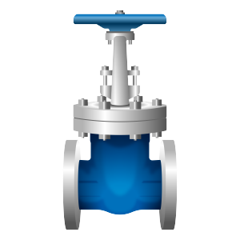

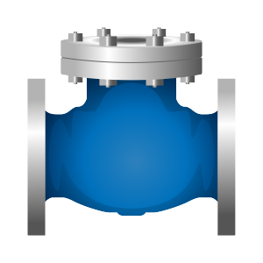

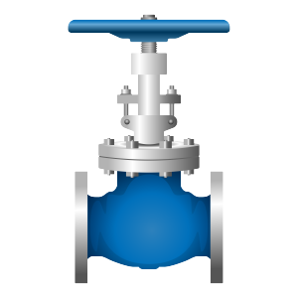

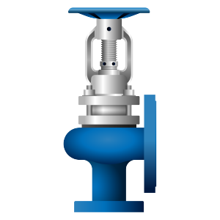

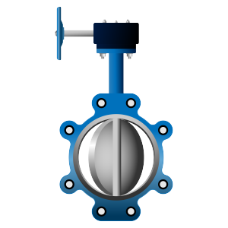

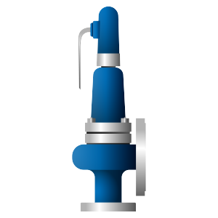

**PROFESSIONAL TO PROVIDE A VARIETY OF VALVE SOLUTIONS**

**YOUR BEST ONE-STOP SHOP FOR INDUSTRIAL VALVES**

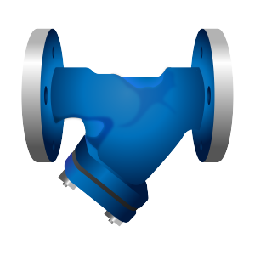

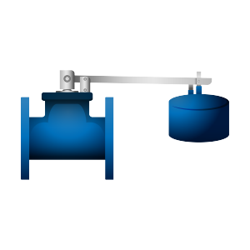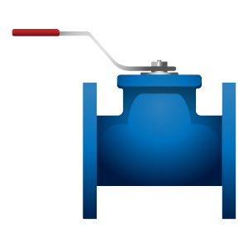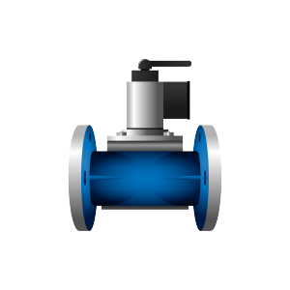

**Suzhou Penbom Fluid Technology Co., Ltd.**

**Apr. 2022**

**Introduction**

SUZHOU PENBOM FLUID TECHNOLOGY CO., LTD. is a developing and privately owned company based in Suzhou China, specializing in distributor and stocking of both standard and customized valves. The owner and most of the engineers have more than 15 years of design and marketing experiences in valve industrial, trading offered all kinds of industrial valves to the worldwide Oil & Gas, E&P, Petrochemical, Chemical, Mining/Minerals, Power companies.

SUZHOU PENBOM FLUID TECHNOLOGY CO., LTD. is an authorized Distributor and Stockist for worldwide excellent valve brand (FZV, BTL, GUANLI) and provide high quality valves and engineering equipment as well as services in industries;

SUZHOU PENBOM FLUID TECHNOLOGY CO., LTD. specializes in providing a ONE-STOP Solution for your valve and flow control needs, we can supply your needs and have it delivered to you at the right price and delivery time. Our products and services are supplied to more than 30 countries worldwide. This global network permits close co-operation with our clients ensuring high service and customer satisfaction.

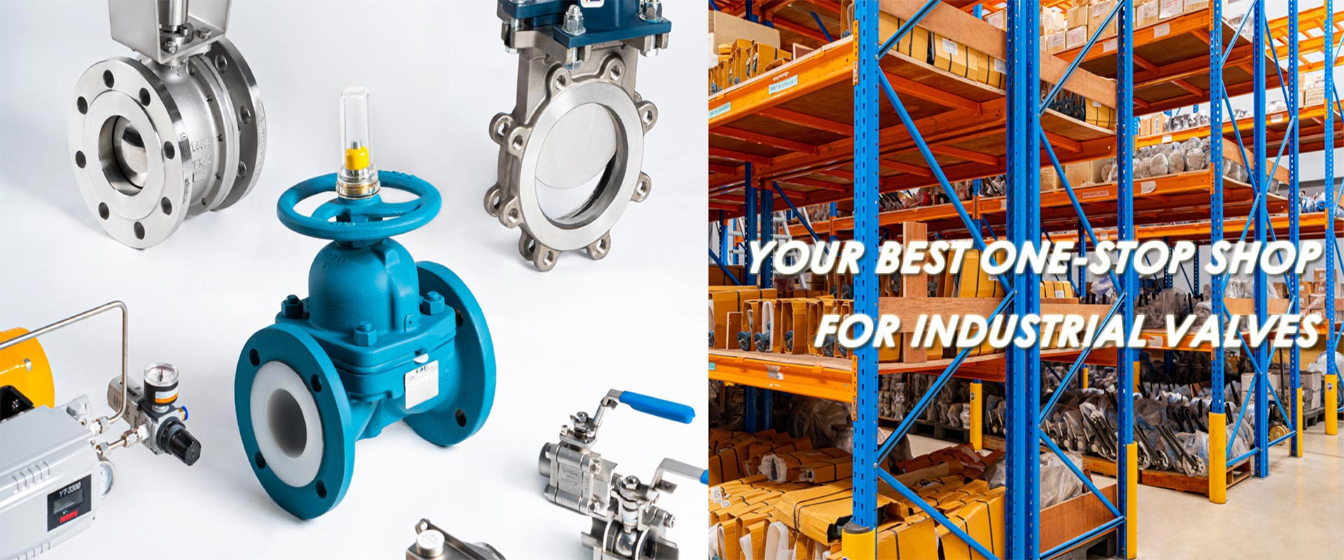

**CONTACT US**

**SUZHOU PENBOM FLUID TECHNOLOGY CO., LTD.**

Add: Room 6383, Building 2, No.116, Chengyang Road, Xiangcheng District,

Suzhou, China

Tel: +86-512-66181812

Cel: +86-13962198698

Fax: +86-512-66181812

Email: Ms. Taylor <[penbom@penbom.com.cn](mailto:penbom@penbom.com.cn)>

**Industrial Valves**

**Vision**

To be the leader of Integrated Engineering Solution Partner specialize in Industrial Valve and Control System with the sincerely deliver high quality products and the experience technical services team.

**Mission**

We provide the various products from trustful partners around the world to meet customer satisfaction with the quality products and value-added engineering service as well as affordably package.

**What we do?**

* 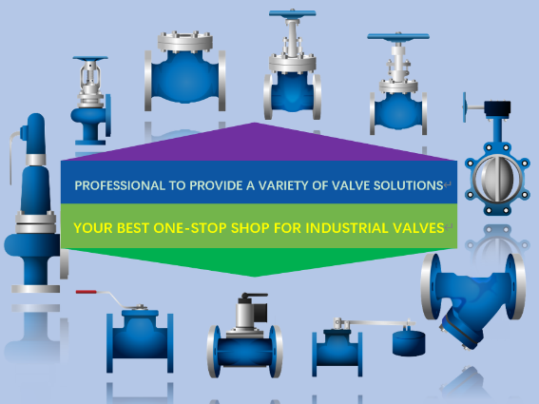Stock a wide range of Gate Valves, Globe Valves, Piston Check Valves, Swing Check Valves, Trunnion Mounted Ball Valves and Floating Ball Valves, Butterfly Valves, Knife Gate Valve.
* Stock valve Brand: FZV, BTL, Guanli
* Offer special valves on short delivery.
* OEM as per request with good quality
* Remain open 24/7 for all your needs.

**How can we support your Business?**

* We work together with you and understanding your needs.
* We deliver the right solutions for all your fluid control solutions.
* We keep closely cooperation with manufacturer and well know what’s you want.
* We have a professional team to support and take care of your project.

**We are Official Distributor for Well-Known Valve Products**

|  |  |
| --- | --- |
|  | An award-winning, progressive and innovative manufacturer, FZV has developed an extensive portfolio of valve products. By implementing strict quality control processes FZV is quickly becoming recognized and accepted as a leading force in the manufacture of valve products by a wide assortment of international clients. |
|  | BTL product range is covering many valve types like ball, gate, globe, check, butterfly, control. All the indicated valve range is being operated within different industries. The majority is being used in the oil & gas, offshore, chemical, power, mining and air separation industry. |
|  | Well-known professional Knife Gate Valve manufacturer, Guanli Knife Gate Valve has been used in Slurry, Mining, Paper, Pharmaceutical, Chemical industrial… etc. All Guanli products are designed and manufactured for the highest level of efficiency and quality. |

**Our product scope:**

|  |  |
| --- | --- |
| **Standard** | ISO,API,BS,JIS,DIN |
| **Product range** | Ball Valve, Gate Valve, Globe Valve, Check Valve, Plug Valve, Triple Offset Butterfly Valve, Cryogenic Valve, Knife Gate Valve. |
| **Size and pressure range** | CLASS 150-600: 1/2”- 60” CLASS 900-1500: 1/2”- 32” CLASS 2500: 1/2”-24” |
| **Casting material** | WCB,LCB,WC6,WC9,C5,C12, CF3,CF3M,CF8,CF8M,  C95500,4A, 5A, Inconel 825/625… etc |
| **Forging material** | A105, LF2, F11, F12, F304, F321, F347, F316,  F304L, F316L, C95800, F51, F53, F55, Inconel… etc. |

**Product**

Ball valves

-- Floating Ball Valves and Trunnion Mounted Ball Valves

|  |  |  |
| --- | --- | --- |
| In addition to our Trunnion Mounted and Floating Ball Valves, we can offer **Top entry Ball Valves**, **Fully welded Ball Valves**, **Cryogenic Service**, **Spring Return Levers**, **weld in pipe pups**, **supply and fitting of Actuators and provide special testing**. We can also offer Painting to your individual specification to all our products if required. All is within our scope of supply, please contact a member of our sales team for more information. | **Sizes** | 1/2” through 46″ |
| **Class** | 150, 300, 600, 800, 900, 1500, 2500 |
| **Materials Forged** | A105, LF2, F316, F304, F321, F347, F11, F5, F22, F51, F55, F53 |
| **Materials Cast** | WCB, LCC, CF8M, CF8, CF8C, WC6, WC9, C5, C12, A890 Gr4A, Gr6A |
| **Trims** | As per you request |
| **Ends** | NPT, BSPT, BSPP, SW, RF, RTJ, Butt Weld, Hub Ends |
| **Design** | BS5351, API6D |

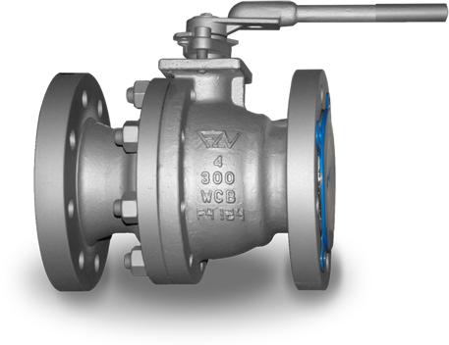 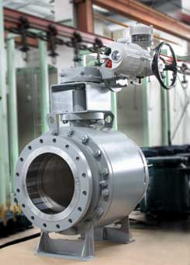 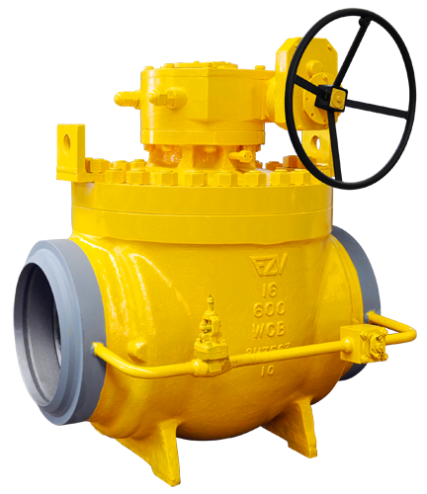 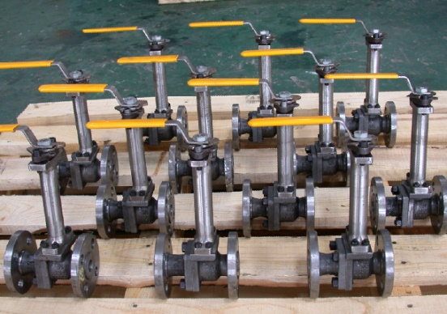 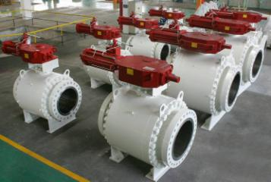

**Product**

Gate valves

-- Forged Gate Valves and Cast Steel Gate Valves

|  |  |  |
| --- | --- | --- |
| As well as our inventory of Forged Gate Valves and Cast Steel Gate Valves, we can accommodate special requirements such as **Pressure Seal Bonnet**, **Bellow Seal**, **Cryogenic service and Extended Body**. We can perform modifications such as **fit By-Passes**, **Extended Hand Wheel**, **Position Indicators** etc. We can provide special testing to all our products if required.  All is within our scope of supply, please contact a member of our sales team for more information. | **Sizes** | 1/2” through 46″ |
| **Class** | 150, 300, 600, 800, 900, 1500, 2500 |
| **Materials Forged** | A105, LF2, F11, F12, F304, F321, F347, F316, 304L, 316L, C61900, F51, F53, F55, Inconel. |
| **Materials Cast** | WCB，LCB, WC6, WC9, C5, C12, CF3,CF3M,CF8, CF8M, C95500, 4A, 5A, Inconel 825/625, etc |
| **Trims** | As per you request |
| **Ends** | NPT, BSPT, BSPP, SW, RF, RTJ, Butt Weld, Hub Ends |
| **Design** | API 600, API 602, BS 5352 |

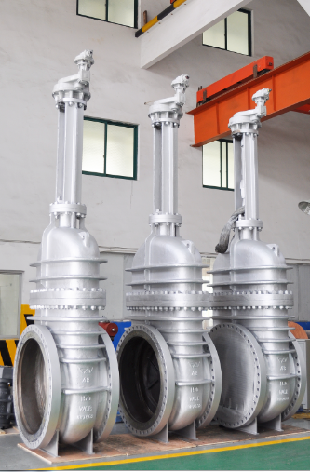 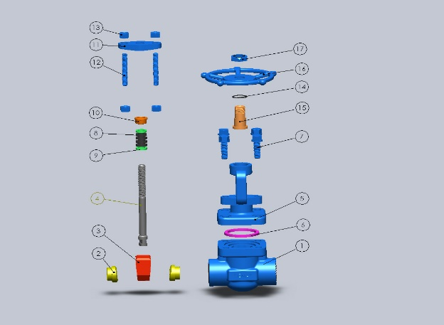 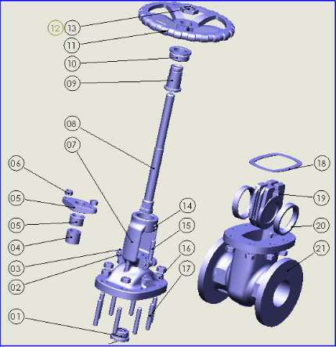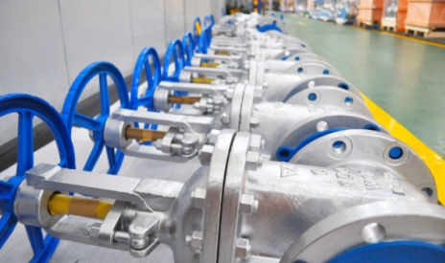

**Product**

Globe valves

--Forged Globe Valves and Cast Steel Globe Valves

|  |  |  |
| --- | --- | --- |
| Alternatively to Forged Globe Valves and Cast Steel Globe Valves, we can also offer special requirements such as **Y Type Globes**, **Angle Globes**, **Pressure Seal Bonnet**, **Bellow Seal**, **Needle Disc**, **Parabolic Disc**, etc. We can perform NDE testing X-Rays, Ultrasonic and 3.2 testing to all our products if required. All is within our scope of supply, please contact a member of our sales team for more information. | Sizes | 1/2” through 20″ |
| Class | 150, 300, 600, 800, 900, 1500, 2500 |
| Materials Forged | A105, LF2, F316, F304, F321, F347, F11, F5, F22, F51, F55, F53 |
| Materials Cast | WCB, LCC, CF8M, CF8, CF8C, WC6, WC9, C5, C12, 4A, 5A |
| Trims | As per you request |
| Ends | NPT, BSPT, BSPP, SW, RF, RTJ, Butt Weld, Hub Ends |
| Design | BS1873, API 600, API 602, BS 5352 |

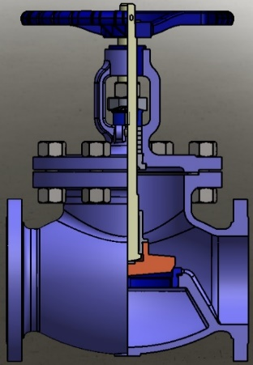 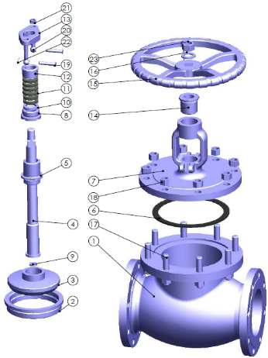 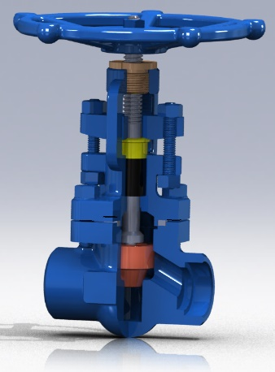

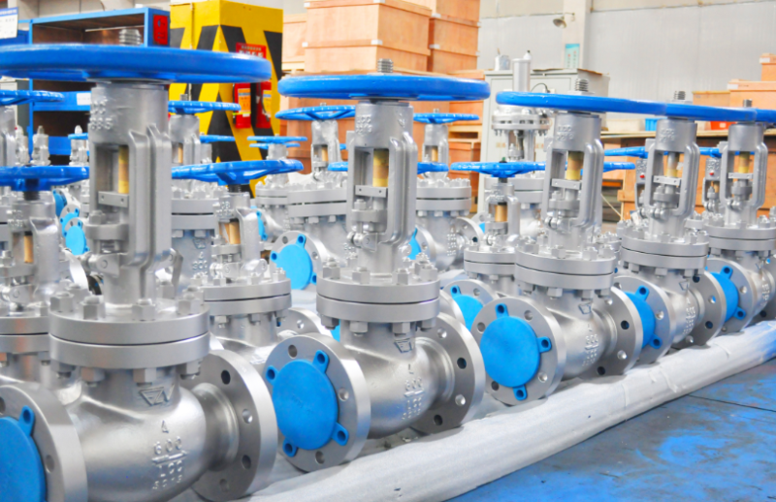

**Product**

Check valves

--Forged Piston, Ball, Dual Plate & Swing Check Valves and Cast Steel Piston, Dual Plate & Swing Check Valves

|  |  |  |
| --- | --- | --- |
| To complement our existing stock of Piston Check and Swing Check Valves, we can also offer special requirements and modifications such as **Pressure Seal Cover**, **Outside Lever and Weight**, **Ball Check Valves**, etc. We can also accommodate 3rd Party Witness Inspection and Testing to all our products if required.  All is within our scope of supply, please contact a member of our sales team for more information | **Sizes** | 1/2” through 20″ |
| **Class** | 150, 300, 600, 800, 900, 1500, 2500 |
| **Materials Forged** | A105, LF2, F316, F304, F321, F347, F11, F5, F22, F51, F55, F53 |
| **Materials Cast** | WCB, LCC, CF8M, CF8, CF8C, WC6, WC9, C5, C12, A890 Gr4A, Gr6A |
| **Trims** | As per you request |
| **Ends** | NPT, BSPT, BSPP, SW, RF, RTJ, Butt Weld, Hub Ends |
| **Design** | BS1868, API 600, API 602, BS 5352 |

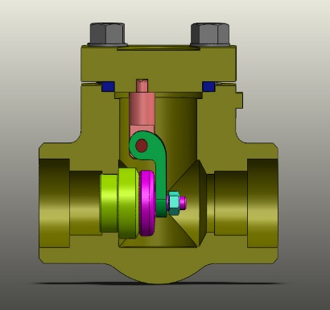 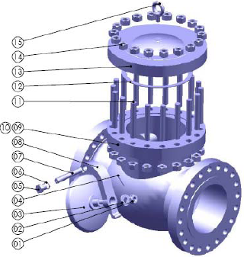 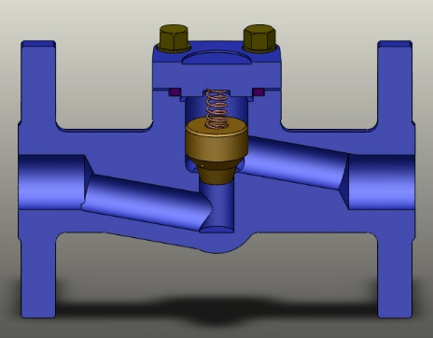

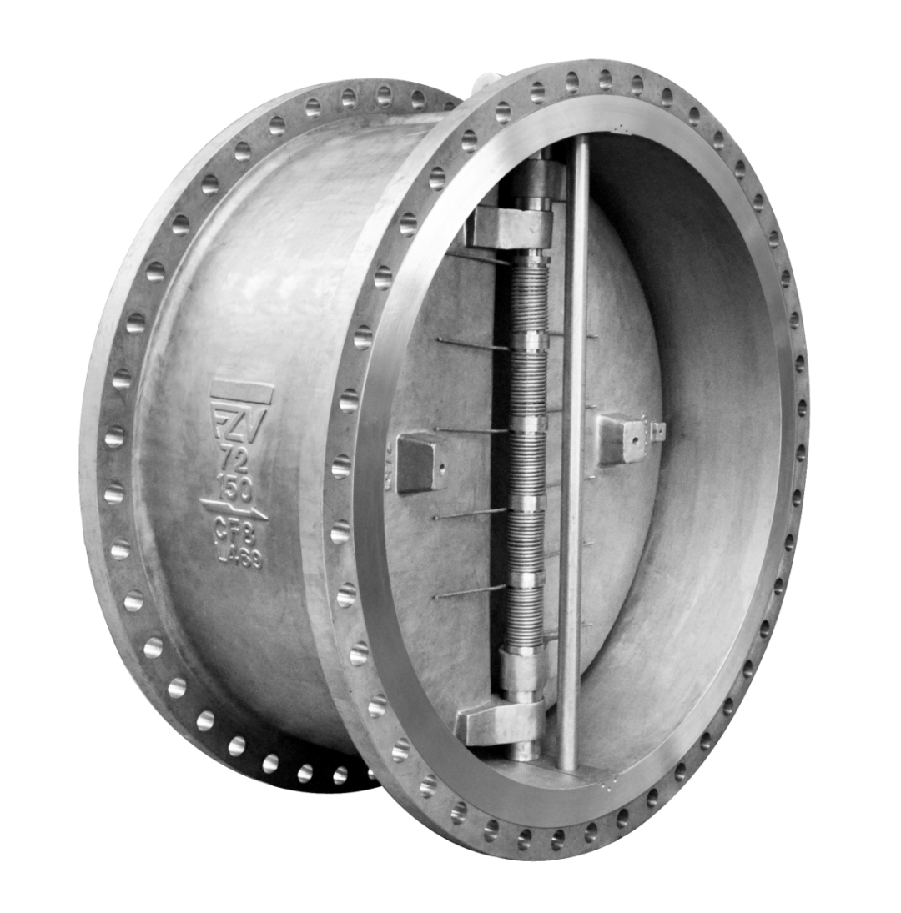

**Product**

Butterfly valves

--Concentric Butterfly Valve, Double Offset Butterfly Valve, Triple offset Butterfly valve

|  |  |  |
| --- | --- | --- |
| We can offer Concentric Butterfly Valve, Double Offset Butterfly Valve, Triple offset Butterfly valve and fitting of Actuators and provide special testing.   All is within our scope of supply, please contact a member of our sales team for more information | **Sizes** | 2” through 60″ |
| **Class** | 150, 300, 600, 900, 1500, 2500 |
| **Materials Cast** | WCB, LCC, CF8M, CF8, CF8C, WC6, WC9, C5, C12, A890 Gr4A, Gr6A |
| **Trims** | CS+ENP; 13Cr; stainless steel; nickel-aluminum bronze |
| **Ends** | Wafer; lug; flange |
| **Design** | BS1868, API 600, API 602, BS 5352 |

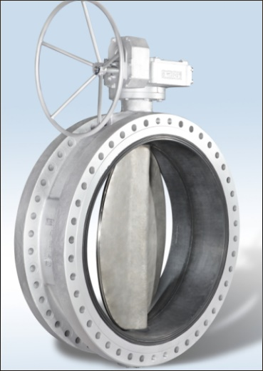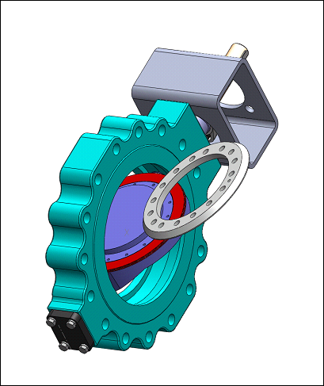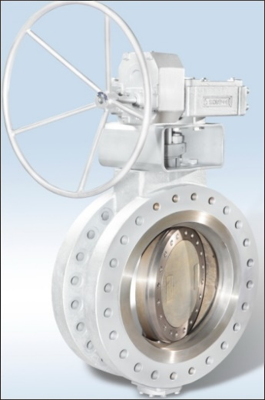

**Product**

Knife Gate Valves

--Knife Gate Valves and Slurry Knife Gate Valves

|  |  |  |
| --- | --- | --- |
| We can offer GUANLI BRAND Knife Gate Valves. Includes: Unidirectional Knife Gate Valves; Bidirectional Knife Gate Valves; Slurry Knife Gate Valves;  All is within our scope of supply, please contact a member of our sales team for more information | **Sizes** | 2” through 24″（DN50-DN600） |
| **Class** | CL150,PN10,PN16,AS2129,JIS 10K |
| **Materials Cast** | Ductile Iron, Stainless Steel, Suplex, Hastelloy, Titanium |
| **Trims** | Knife: SS304,SS316,SS2205 Seat: NBR,EPDM,FKM,Metal TO Metal |
| **Ends** | Wafer; Lug; Semi-Lug; Flange |
| **Design** | BS1868, API 600, API 602, BS 5352 |



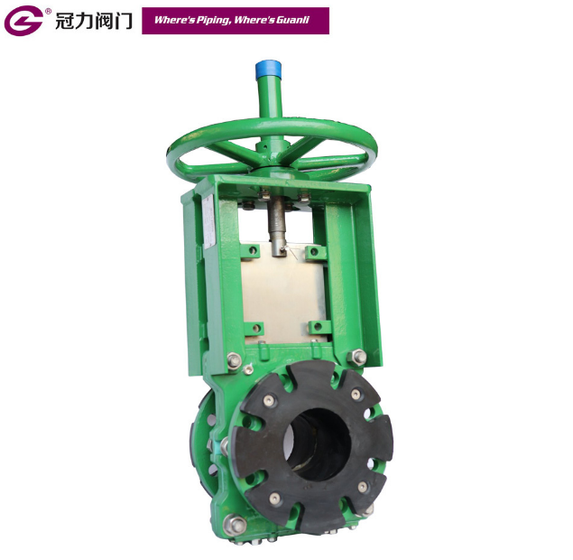

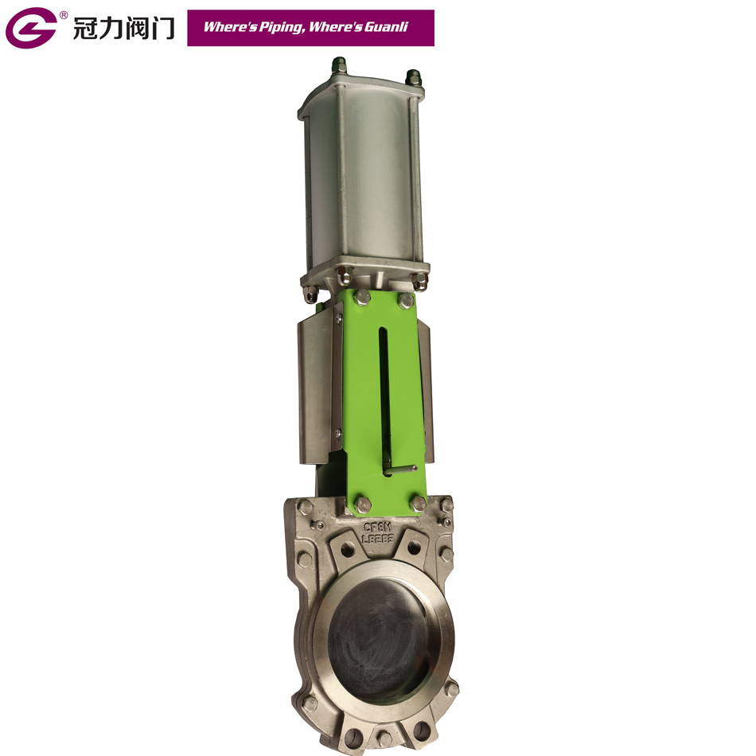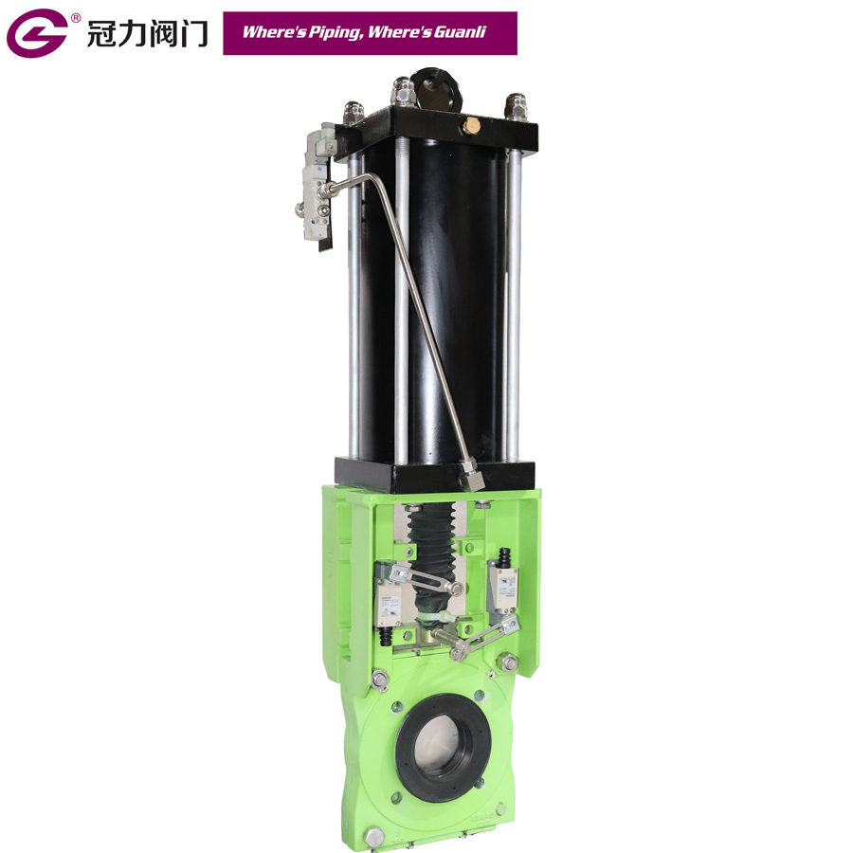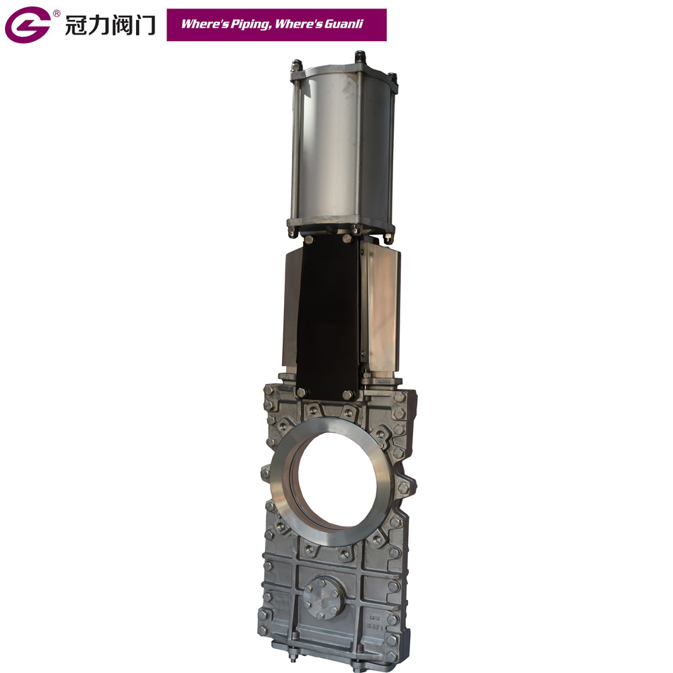

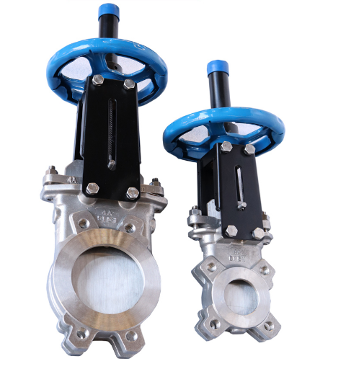

**Product**

Other Products

|  |  |
| --- | --- |
|  | **[Y-Pattern Strainer](http://en.botelitech.com/product/6-14-y-pattern-strainer.html" \o "Y-Pattern Strainer)**  Material: Carbon Steel, Stainless Steel  Standard: ASTM, GB, API, DIN, JIS  Size: 2” to 24”  Rating: Class150~300  Medium: Gas, Water  Facing: RF |
|  | **Tee**  Material: Carbon Steel, Stainless Steel  Standard: ASTM, GB, API, DIN, JIS  Size: 2” to 24”  Medium: Gas, Water  Facing: RF, SW, NPT |
|  | **Plug Valve**  Material: Carbon Steel, Stainless Steel  Standard: ASTM, GB, API, DIN, JIS  Size: 2” to 24”  Rating: Class150~600  Facing: RF / RTJ |
|  | **Flange**  Material: Carbon Steel, Stainless Steel, Alloy steel  Standard: ASME, BS, DIN, JIS  Size: 1/2” to 60”  Rating: Class150~2500 Facing: RF / RTJ |

**Market**

Penbom were delivered worldwide to Oil & Gas, E&P, Petrochemical, Chemical, Mining/Minerals, Power generation and other industrial processes.

Our international specifications, the broad knowledge and technical ability enables us to serve the end-users all around the world.

|  |  |  |
| --- | --- | --- |
|  |  |  |
| Petroleum Offshore Chemical | | |
|  |  |  |
| Power Marine Water Treatment | | |

**Ours valuable customers:**









**Quality Control**

As an experienced valve supplier in China, Penbom has won reliance from many customers for its stable quality and superior performance of valves.

Out team attaches high importance to quality. We have whole complete strict inspection steps, which include from raw material, machining process, hydraulic test, painting, packing to shipment. Inspectors are responsible for their inspected valves, original inspection records are preserved, 3.1 Cert is provided for each valve.

To keep stable quality, our team has long cooperation with TPI Company, like France BV, Germany TUV and Norway DNV. Customers' satisfactory is our great aim.

We are pleased to take you on a virtual tour of Penbom's quality control, following photos show how our inspection department and technical department work on valves, including each step involved in the manufacturing, testing and package.

**Penbom inspect valves as below steps:**

1. **Raw material**

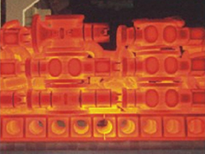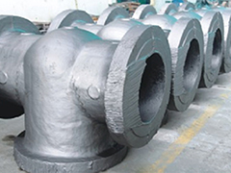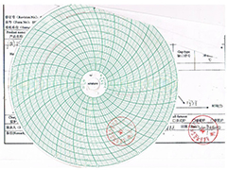

|  |  |  |
| --- | --- | --- |
| Raw Material | Heat treatment | Heat treatment report |

1. **NDT tests**

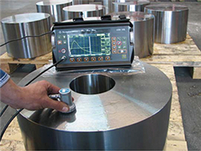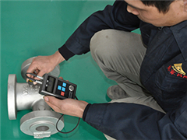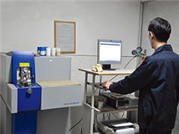

|  |  |  |
| --- | --- | --- |
| Ultrasonic inspection | Wall thickness inspection | Standing PMI inspection |

1. **Dimension control**

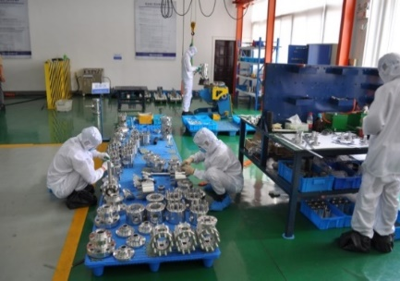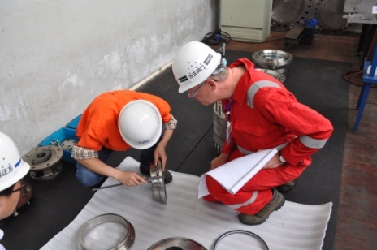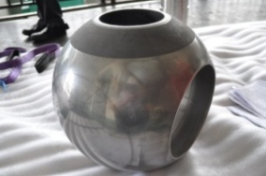

|  |  |  |
| --- | --- | --- |
| Dimension inspection | Dimension inspection | Dimension inspection |

1. **Assembly**

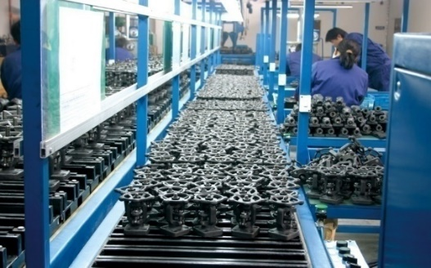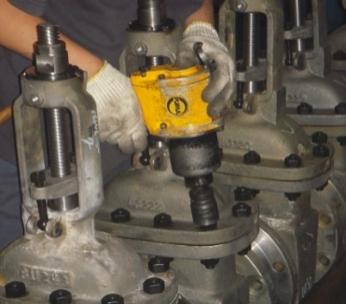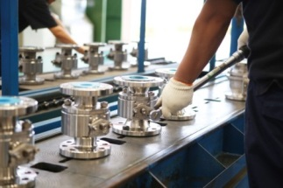

|  |  |  |
| --- | --- | --- |
| Ball valve | Cast GGC | Forged GGC |

1. **Testing**

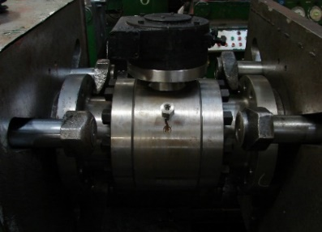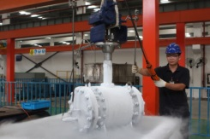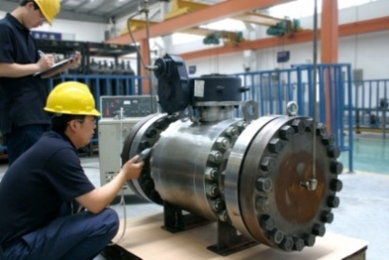

|  |  |  |
| --- | --- | --- |
| Hydraulic test | Cryogenic test | Fugitive Emission Test |

1. **Painting**

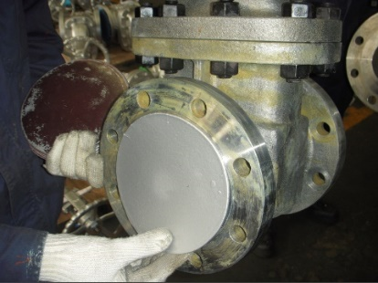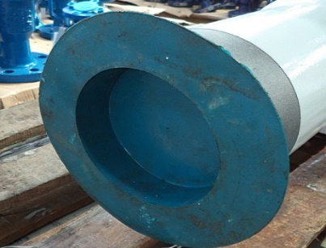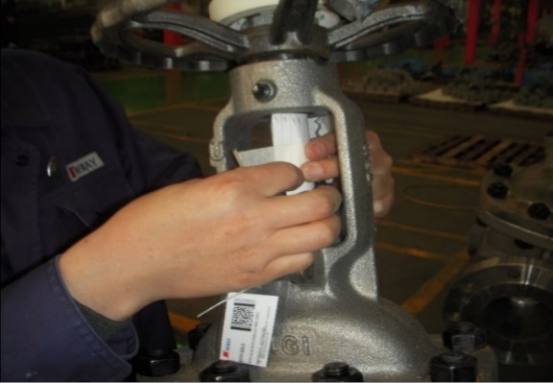

|  |  |  |
| --- | --- | --- |
| Face protection | Face protection | Stem protection |

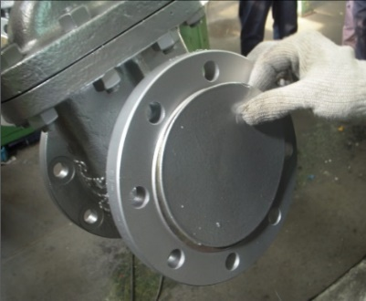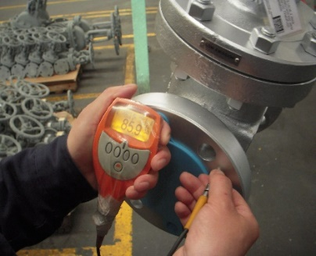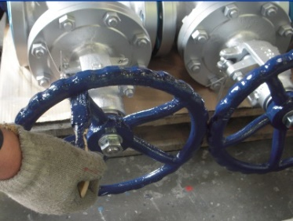

|  |  |  |
| --- | --- | --- |
| Painting | Thickness test | Painted |

1. **Package**

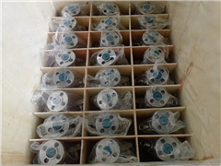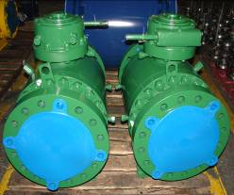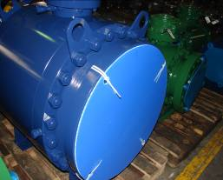

|  |  |  |
| --- | --- | --- |
| Packing | End protection | Packing |

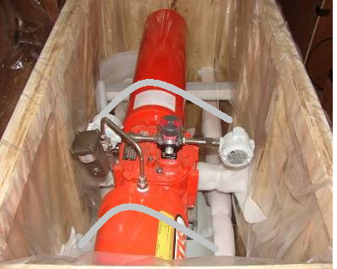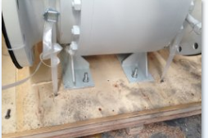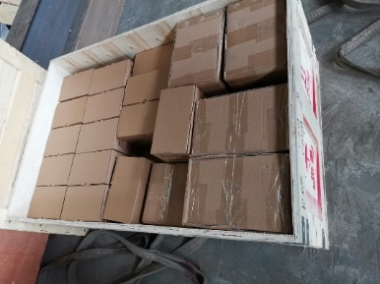

|  |  |  |
| --- | --- | --- |
| Plywood box | Palletizing | Packing |

1. **Shipping**

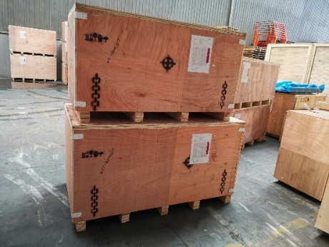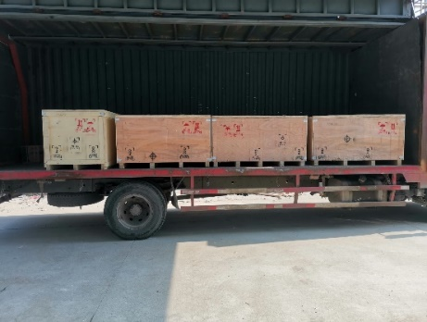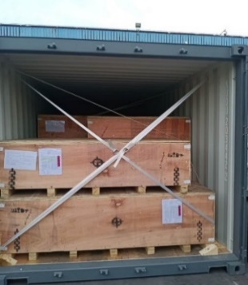

|  |  |  |
| --- | --- | --- |
| Shipping Marking | Loading | Loading |

**Our Global Sales Network**

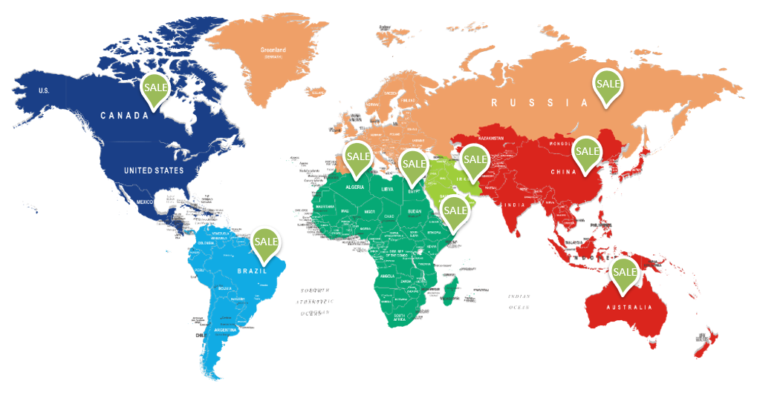



**SUZHOU PENBOM FLUID TECHNOLOGY CO., LTD.**

Add: Room 6383, Building 2, No.116, Chengyang Road,

Xiangcheng District, Suzhou, China

Tel: +86-512-66181812

Cel: +86-13962198698

Email: Ms. Taylor <[penbom@penbom.com.cn](mailto:penbom@penbom.com.cn)>

Web: www.penbom.com.cn